
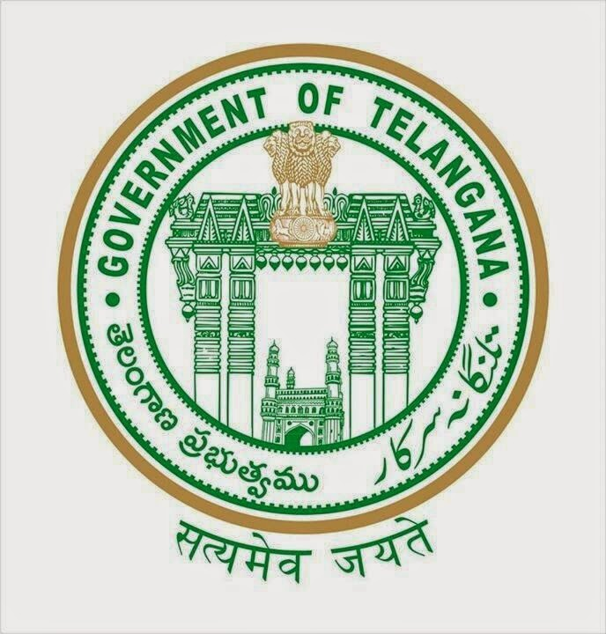
TELANGANA TRIBAL WELFARE RESIDENTIAL DEGREE COLLEGE FOR WOMEN, MEDAK
AFFILIATED TO OSMANIA UNIVERSITY, HYDERABAD
NEAR INDIRA GANDHI STADIUM, YTC BUILDING, MEDAK
Website:Telangana Tribal Welfare Residential Degree College
(ttwrdcs.ac.in)

PROGRAMS ORGANISED UNDER MOU

MOU WITH NEHRU YUVA KENDRA AND TELANGANA TRIBAL WELFARE RESIDENTIAL DEGREE COLLEGE FOR WOMEN, MEDAK

Yuva Utsav Competitions at GDC Medak by NYK Medak
Yuva Utsav is the flagship youth festival organized by Nehru Yuva Kendra Sangathan (NYKS) under the Ministry of Youth Affairs & Sports. In 2025, this nationwide cultural initiative is carried out across district, state, and national levels, under the theme “Yuva Shakti se Jan Bhagidari” and “India@2047”, rooted in the Panch Pran (five pledges) of nation-building and unityStudents from our institution actively participated in the Yuva Utsav competitions held at Government Degree College, Medak, organized by Nehru Yuva Kendra (NYK) Medak. The event featured a variety of cultural and creative competitions aimed at showcasing youth talent and promoting national integration.
Our students took part in several events including elocution, painting, music, dance, and essay writing, and made us proud by winning multiple prizes across categories. Their enthusiastic participation and outstanding performances were truly commendable.
We congratulate all the participants and winners for their hard work and dedication. Special thanks to NYK Medak and GDC Medak for providing such a vibrant platform for youth expression.
1. Science mela individual third prize - P. Nandini MPCS III YEAR with 1500/- cash prize.
2. Young writers second prize - Sowmya MPCS III YEAR with cash prize 1500/-
3. Young artist painting competition - P. Nandini MPCS III Year with cash prize 1000/-
4. Photography competition - Lavanya MPCS III YEAR with cash prize 2500/-
5. Declamation competition - Shailaja BCOM III YEAR with cash prize 1500/-
6. Cultural fest akshitha and team second prize - with cash prize of 5000/-

Lavanya is selected for state level competition
